Monday

- 764,789 + 85,987 = 850,776
- 687,694 + 468,375 = 1,156,069
- 853,875 + 49,697 = 903,572
- 580,113 – 94,786 = 485,327
- 104,405 – 28,817 = 75,588
- 453,021 – 86,548 = 366,473
- 674 x 86 = 57,964
- 765 x 834 = 638,010
- 1,645 ÷ 7 = 235
- 1,170 ÷ 18 = 65

Tuesday
- Write twenty-five million, thirty-eight thousand, and four in numerals.
25,038,004

- Write 72,003,803 in words.
Seventy-two million, three thousand, eight hundred and three.

- True or False? 3,708,412 is written as three million, seven hundred and eighty thousand, four hundred and twelve. Prove it!
False, it’s three million, seven hundred and eight thousand, four hundred and twelve

- True or false? 0.75 is seventy-five hundredths. True

- True or false? 3.5 is thirty-five hundredths. False, it is 35 tenths or 350 hundredths

- Write three fifths as a decimal. 0.6

- Write 0.23 as a fraction. $\frac{23}{100}$

- Write 46% as a fraction. $\frac{46}{100}$ or $\frac{23}{50}$

- Write 38% as a decimal. 0.38

- Write a fraction which is equivalent to 75%? Any fraction which is equivalent

to $\frac{75}{100}$ or $\frac{3}{4}$

Wednesday

- $\frac{2}{5}$ + $\frac{12}{20}$ = 1 or $\frac{20}{20}$

- $\frac{5}{12}$ + $\frac{7}{8}$ = $\frac{31}{24}$ or $1\frac{7}{24}$

- $\frac{6}{9}$ - $\frac{2}{18}$ = $\frac{10}{18}$ or $\frac{5}{9}$

- $\frac{3}{5}$ x 5 = $\frac{15}{5}$ or 3

- $\frac{2}{3}$ x $\frac{7}{8}$ = $\frac{14}{24}$ or $\frac{7}{12}$

- $\frac{8}{12}$ ÷ 3 = $\frac{8}{36}$ or $\frac{2}{9}$

- $3\frac{1}{4}$ + $2\frac{3}{12}$ = $\frac{65}{12}$ or $5\frac{5}{12}$

- $6\frac{4}{15}$ - $2\frac{1}{5}$ = $\frac{61}{15}$ or $4\frac{1}{15}$

- $6\frac{5}{8}$ = $\frac{53}{8}$

- $\frac{ 52}{6}$ = $8\frac{4}{6}$

Thursday

- The temperature in Sydney was 35°. In London it was -8°. What is the difference between the temperatures? 43°

- At 4am the temperature in Portsmouth was -4.5°. At 2pm it had increased by 12°. What was the temperature at 2pm? 16.5°

- The temperature decreased by 23.5° between 8pm and 6am. At 8pm it was 17°. What was the temperature at 6am? -6.5°

- The difference in temperatures was 13.5°. The highest temperature was 12°. What was the lowest temperature? -1.5°

- Over a period of five days, the temperature was taken at 12 midday.
Monday = 10.5°
Tuesday = 12.3°
Wednesday = 11.8°
Thursday = 15.3°
Friday = 12.1°
What was the mean temperature? 12.4°

- A) The ratio of giraffes to elephants at the zoo is ___3:2____________
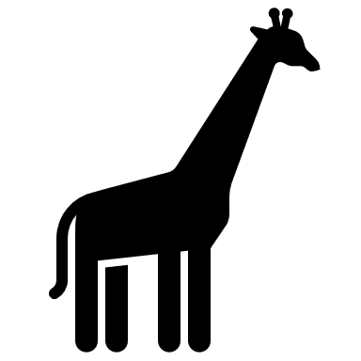

B) Using this ratio, if there are 12 giraffes in the zoo, how many elephants would there be?
8 elephants
c) Using this ratio, all together there are 45 giraffes and elephants in the zoo. How many of each are there? 27 giraffes & 18 elephants

- a) To make 2 litres of mocktail, the ratio of ingredients is: 1-part orange juice, 2- parts apple juice and 2- parts lemonade. If I used 800ml of apple juice, how much orange juice would I need? 400ml

- Using the same ratio, how much of each ingredient would I need to make 2.5 litres?
Orange juice = 500ml, Apple juice = 1000ml, Lemonade = 1000ml
- Following the same ratio, if I used 600ml of orange juice in my mocktail, how much apple juice would I need? 1.2litres or 1200ml
- If I used 600ml of orange juice, how much mocktail would I have made all together?
3 litres or 3000ml

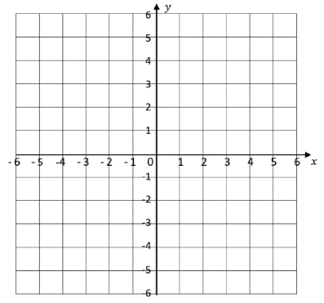
Friday
1) Plot the given points.

A (3,-4)

B (-5,3)

C (-2,-3)

D (5,1)

- What are the co-ordinates of the shapes?
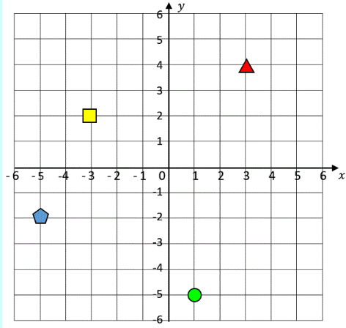

Triangle = (3,4)

Square = (-3,2)

Pentagon = (-5,-2)

Circle = (1,-5)

3A) How much liquid is in each jug?
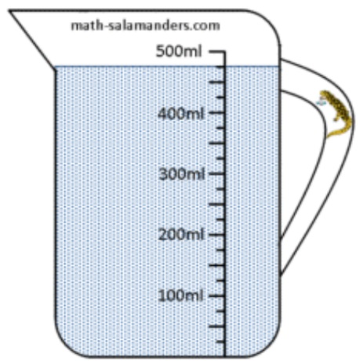
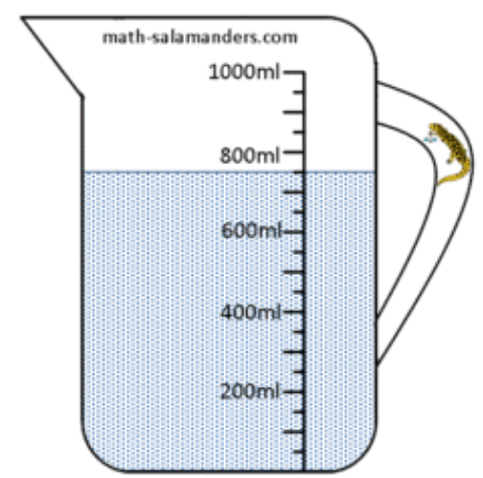

___750_____ml ____475_____ml

b) How much liquid is there in total? ___1.225_____litres

c) What is the difference between the amount of liquid in each jug? ____275_____ml

4)A) How much does each parcel weigh?
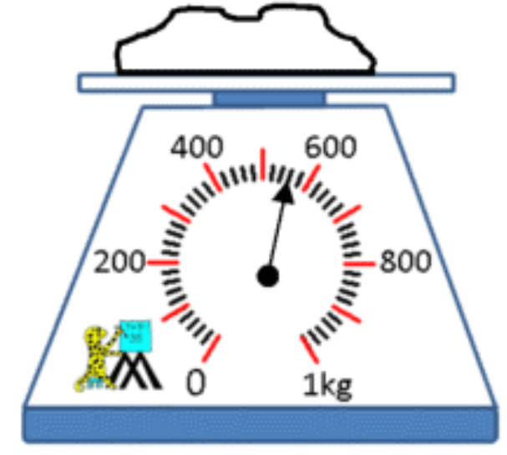
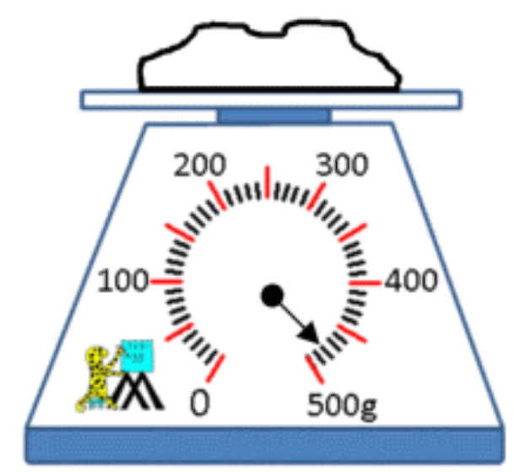

_____0.48_______ kg _____560______ g

b) What is the difference in weight between the two parcels? 80g

c) What is the total weight of the two parcels? 1.04kg or 1040g

