Wider Curriculum Home Learning – Film Week
This week our English tasks all linked to different films
Design a Character  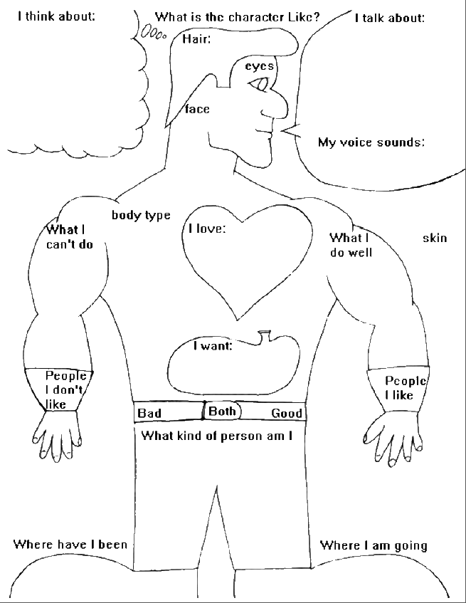  If you were making a short film, who would your main character be? It could  be human, animal, robotic  or even alien, but you  will need to think about  what they look like,  their special skills as well  as their personality.  There are no  limits to your  imagination! | Draw a Sound Creature  Film makers often use theme music, or specific sounds for different characters. Click on the link below and try using sound to inspire your own Sound Creature  https://www.tate.org.uk/kids/make/art-technology/draw-sound-creature  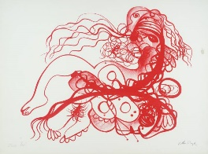  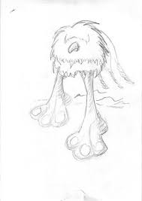  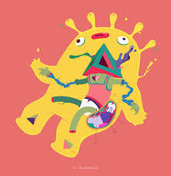 | Create a soundtrack  Music is crucial in the film industry, it helps to create atmosphere. Try watching a movie clip with the sound off, then with the sound on.  If you play an instrument you could create a piece of music to accompany a scene from a movie, or you could choose a piece of music or song for an existing character or one you have created. Think about the mood of the scene and how the music helps to create atmosphere.
Make a Storyboard  Create your own storyboard for a short film or animation.  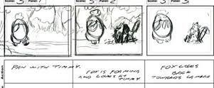  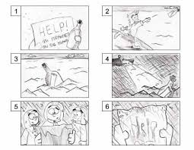  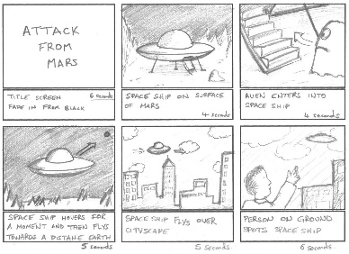 | Get animating  Create your own animations. You could do this using toys and an IPad, or using a programme such as Pivot animation  https://pivotanimator.net/  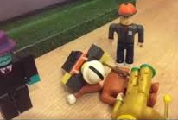  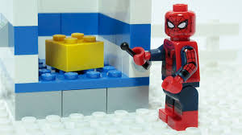 | Voice Overs  You could create your own voiceover for film trailer? Or you could mute your favourite film and narrate what is happening. What do you wish character’s really said? (make sure your narration is appropriate)  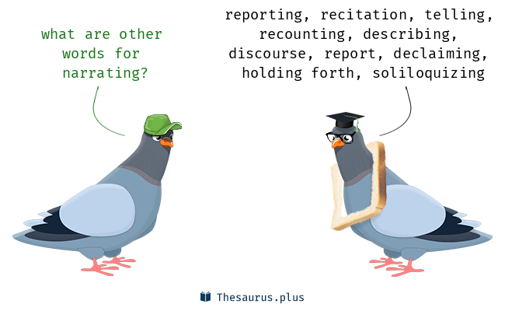
Remember to share your work with your teacher using seesaw or the class email address

