Wider Curriculum: Environment
Wednesday 22nd April is Earth Day
https://www.earthday.org/
Earth Day is celebrated every year on the 22 of April for the last 47 years. In 1970, an American Senator from Wisconsin, created this national day to create awareness of the environment and how we treat nature. Today this Earth Day is celebrated as an international event in 193 countries.
Choose from the following tasks:
- Reduce, Reuse, Recycle – collect your household recyclables and use them to create something new, this could be a piece of artwork, a scarecrow, wind chime, get creative, the possibilities are endless…
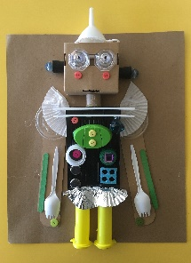

- What is a FOODPRINT - investigate what a foodprint is and how you could help save the environment by reducing yours
- Artists for the Earth is a global campaign to connect with arts organizations and artists everywhere in order to engage the public with the critical issues of the environment. Art has the power to reach people personally, establishing a deeper understanding and emotional connection with what is happening to our planet. Create your own piece of art for the campaign.
- Endangered animals – Research and endangered animal, where do they live in the world? Why are they endangered, how many are left in the wild? What is being done to protect them? Create a fact file or poster about your chosen animal.
- Watch a nature documentary, Seven Worlds One Planet on BBC iplayer is great!

