Monday

- 749, 678 + 84,567 =
- 2,693,997 + 978,483 =
- 96,005 – 12,847 =
- 803,248 – 64,489 =
- 564 x 87 =
- 867 x 69 =
- 512 ÷ 16 =
- 3776 ÷ 8 =
- 3684 = 3.684 x _______
- 9.73 = _____ ÷ 100
Tuesday
- Round 453,991
- To the nearest 10 =
- To the nearest 100 =
- To the nearest 1000 =
- To the nearest 10,000 =
- What is the value of the underlined digits?
- 96, 263,918
- 3,493,416
- 8,03,401.09
- 2,522,903

- Write this number in words: 305,309,086

- Write this number using numerals: Eighty-three million, four hundred and twenty thousand, two hundred and six

- Six million, two hundred and sixty thousand, three hundred and fourteen is written as
6,206,314. True or False? Prove it!

Wednesday

- Find 18% of 450

- Find 23% of 450

- Find 60% of 450

- Find 87% of 450

- Find 99% of 450

- 96.92 + 35.78 =

- 354.78 + 256.9 =

- 257.08 – 64.2 =

- 703.01 – 37.25 =

- 503.06 x 1000 =

Thursday

- _______ days = 1 year
- _______ weeks = 1 year
- 72 hours = ________ days
- 270 minutes = _____ hours and ______ minutes
- 780 seconds = _________ minutes
- 5 hours and 12 minutes = _________ minutes
- 8.32 kg = ________ g
- 5025ml = ________ litres
- 14.75 km = _________ m
- 3250 mm = _________ cm

Friday

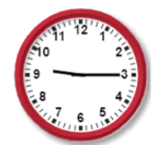
- If this clock represents the time in the morning, what would a digital representation say 15and a half hours later?

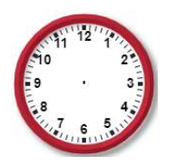
- Draw the hands on the clock to represent 21:53

3)
a) Jim started the race at 09:30. He completed it at 11:28. How long did it take him?

b) Frank did the same race as Jim but completed it in a time of 2 hours and 36 minutes. What time did Frank finish?

c) Who was fastest and by how much?

4) Write today’s date in Roman Numerals.

- What number is represented? MMCCCLXIV

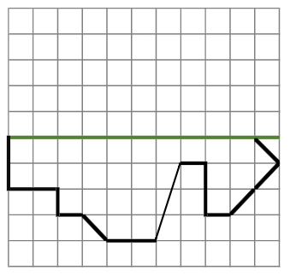

- Reflect the image

- Find the missing angles:
