Monday

- 64,789 + 8,987 = 73,776
- 87,694 + 68,375 = 156,069
- 153,875 + 49,627 = 203,502
- 83,057 – 4,786 = 78,271
- 94,405 – 28,817 = 65,588
- 453,621 – 86,548 = 367,073
- 74 x 53 = 3,922
- 465 x 34 = 15,810
- 1,645 ÷ 7 = 235
- 1,960 ÷8 = 245

Tuesday
- Write five million, three hundred and twenty thousand, nine hundred and fifty-four in numerals. 5,320, 954

- Write 12,703,893 in words. Twelve million, seven hundred and three thousand, eight hundred and ninety-three

- True or False? 3,708,412 is written as three million, seven hundred and eighty thousand, four hundred and twelve. Prove it! False, it is three million, seven hundred and eight thousand, four hundred and twelve.

- True or false? 0.75 is seventy-five hundredths. True
- True or false? 3.5 is thirty-five hundredths. False, it is 35 tenths or 350 hundredths
- Write three tenths as a decimal. 0.3
- Write 0.25 as a fraction. $\frac{1}{4}$ or $\frac{25}{100}$
- Write 46% as a fraction. $\frac{46}{100}$
- Write 75% as a decimal. 0.75
- Write a fraction which is equivalent to 50%? Any fraction equivalent to $\frac{1}{2}$ so any fraction where the numerator is half of the denominator

Wednesday

- $\frac{2}{5}$ + $\frac{4}{5}$ = $\frac{6}{5}$ or $1\frac{1}{5}$

- $\frac{5}{8}$ + $\frac{2}{4}$ = $\frac{9}{8}$ or $1\frac{1}{8}$

- $\frac{6}{9}$ - $\frac{2}{9}$ = $\frac{4}{9}$

- $\frac{3}{4}$ x 2 = $\frac{6}{4}$ or $1\frac{1}{2}$

- $\frac{5}{10}$ x $\frac{2}{5}$ = $\frac{10}{50}$ or $\frac{1}{5}$

- $\frac{8}{12}$ ÷ 2 = $\frac{8}{24}$ or $\frac{4}{12}$ or $\frac{1}{3}$

- $3\frac{1}{4}$ + $2\frac{3}{4}$ = 6

- $6\frac{4}{5}$ - $2\frac{1}{5}$ = $4\frac{3}{5}$

- $2\frac{5}{8}$ = $\frac{21}{8}$

- $\frac{ 25}{6}$ = $4\frac{1}{6}$

Thursday

- The temperature in Sydney was 35°. In London it was -3°. What is the difference between the temperatures? 38°

- At 4am the temperature in Portsmouth was -4°. At 2pm it had increased by 12°. What was the temperature at 2pm? 8°

- The temperature decreased by 13° between 8pm and 6am. At 8pm it was 9°. What was the temperature at 6am? -4°

- The difference in temperatures was 15°. The highest temperature was 12°. What was the lowest temperature? -3°

- Over a period of five days, the temperature was taken at 12 midday.
Monday = 10°
Tuesday = 12°
Wednesday = 11°
Thursday = 15°
Friday = 12°
What was the mean temperature? 12° (Add them up and divide by the number of amounts)

- A) The ratio of giraffes to elephants at the zoo is ____4:1___________
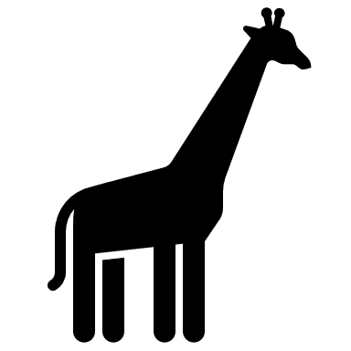
B) Using this ratio, if there are 8 giraffes in the zoo, how many elephants would there be?
2 elephants
c) If there are 4 elephants in the zoo, how many giraffes would there be? 16 giraffes

- a) To make 1 litre of mocktail, the ratio of ingredients is: 1-part orange juice, 2- parts apple juice and 2- parts lemonade. If I used 400ml of apple juice, how much orange juice would I need? 200ml

- Using the same ratio, how much of each ingredient would I need to make 2 litres? 400ml of orange juice, 800 ml of apple juice and 800ml of lemonade.

- Following the same ratio, if I used 600ml of orange juice how much apple juice and lemonade would I need? 1200ml of apple juice and 1200ml of lemonade

- How much mocktail would I have made? 3 litres

Friday

- A) Plot the given points.
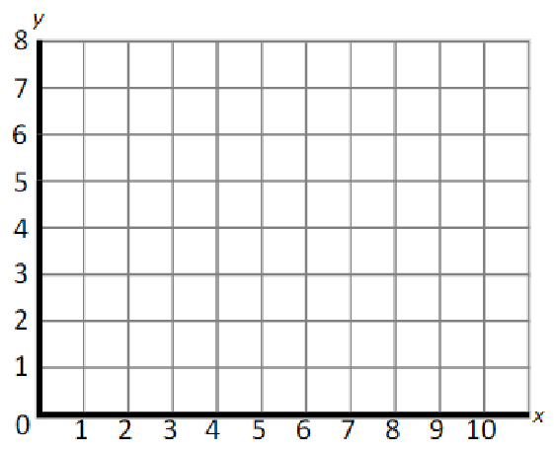

A = (2,5)
B = (2,8)
C = (5,5)

b) What are the co-ordinates of the missing point to make a square? D = (5,8)

c) Translate the square (right 4, down 3). What are the new co-ordinates of each point?
A =(6,2) B = (6,5) C = (9,2) D = (9,5)

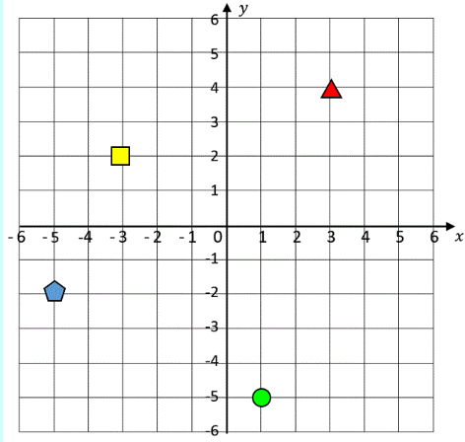

What are the co-ordinates of the shapes?

Square = (-3,2)
Triangle = (3,4)
Circle = (1, -5)
Pentagon = (-5,-2)

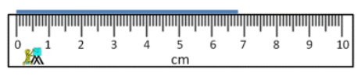
- What length is shown on the ruler? 6.8 cm

- A) How much liquid is in the jug? 275ml
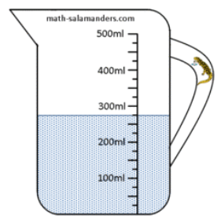

b) How much more liquid is needed to reach half a litre? 225ml

- A) How heavy? 880g
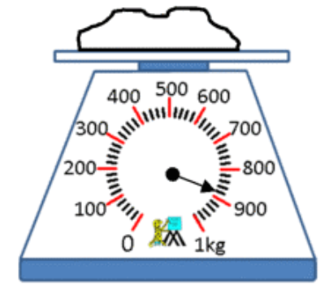

b) What would double this weight be?
1.76 kg

