Monday

- 64,789 + 8,987 =
- 87,694 + 68,375 =
- 153,875 + 49,627 =
- 83,057 – 4,786 =
- 94,405 – 28,817 =
- 453,621 – 86,548 =
- 74 x 53 =
- 465 x 34 =
- 1,645 ÷ 7 =
- 1,960 ÷8 =

Tuesday
- Write five million, three hundred and twenty thousand, nine hundred and fifty-four in numerals.
- Write 12,703,893 in words.
- True or False? 3,708,412 is written as three million, seven hundred and eighty thousand, four hundred and twelve. Prove it!
- True or false? 0.75 is seventy-five hundredths.
- True or false? 3.5 is thirty-five hundredths.
- Write three tenths as a decimal.
- Write 0.25 as a fraction.
- Write 46% as a fraction.
- Write 75% as a decimal.
- Write a fraction which is equivalent to 50%?

Wednesday

- $\frac{2}{5}$ + $\frac{4}{5}$ =

- $\frac{5}{8}$ + $\frac{2}{4}$ =

- $\frac{6}{9}$ - $\frac{2}{9}$ =

- $\frac{3}{4}$ x 2 =

- $\frac{5}{10}$ x $\frac{2}{5}$ =

- $\frac{8}{12}$ ÷ 2 =

- $3\frac{1}{4}$ + $2\frac{3}{4}$ =

- $6\frac{4}{5}$ - $2\frac{1}{5}$ =

- $2\frac{5}{8}$ = $\frac{?}{8}$

- $\frac{ 25}{6}$ = $?\frac{?}{6}$

Thursday

- The temperature in Sydney was 35°. In London it was -3°. What is the difference between the temperatures?

- At 4am the temperature in Portsmouth was -4°. At 2pm it had increased by 12°. What was the temperature at 2pm?

- The temperature decreased by 13° between 8pm and 6am. At 8pm it was 9°. What was the temperature at 6am?

- The difference in temperatures was 15°. The highest temperature was 12°. What was the lowest temperature?

- Over a period of five days, the temperature was taken at 12 midday.
Monday = 10°
Tuesday = 12°
Wednesday = 11°
Thursday = 15°
Friday = 12°
What was the mean temperature?

- A) The ratio of giraffes to elephants at the zoo is _______________
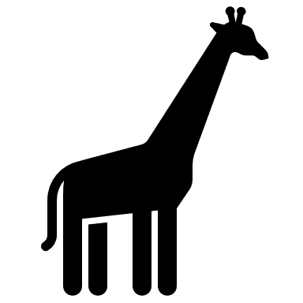
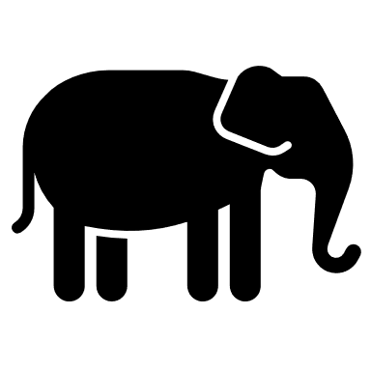

B) Using this ratio, if there are 8 giraffes in the zoo, how many elephants would there be?

c) If there are 4 elephants in the zoo, how many giraffes would there be?

- a) To make 1 litre of mocktail, the ratio of ingredients is: 1-part orange juice, 2- parts apple juice and 2- parts lemonade. If I used 400ml of apple juice, how much orange juice would I need?

- Using the same ratio, how much of each ingredient would I need to make 2 litres?

- Following the same ratio, if I used 600ml of orange juice how much apple juice and lemonade would I need?

- How much mocktail would I have made?

Friday

- A) Plot the given points.
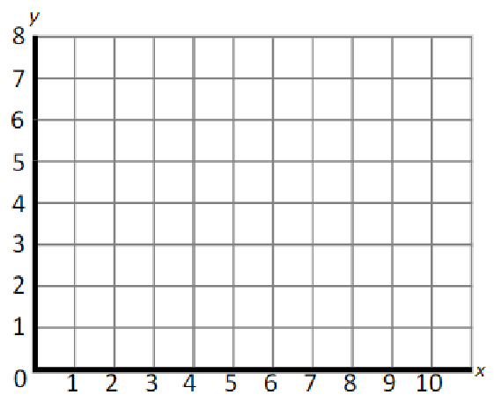

A = (2,5)
B = (2,8)
C = (5,5)

b) What are the co-ordinates of the missing point to make a square?

c) Translate the square (right 4, down 3). What are the new co-ordinates of each point?

- What are the co-ordinates of the shapes?

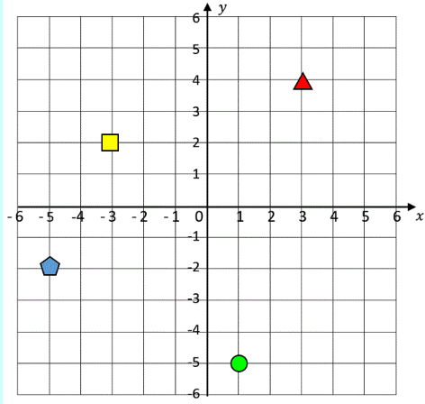

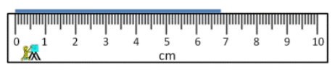
- What length is shown on the ruler? _________ cm

- A) How much liquid is in the jug? _________ml
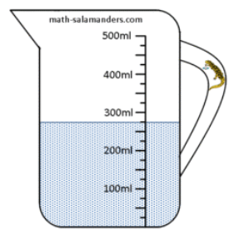

b) How much more liquid is needed to reach half a litre? ________ml

- A) How heavy?
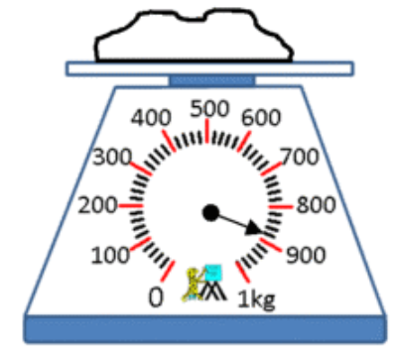

b) What would double this weight be?
______kg

