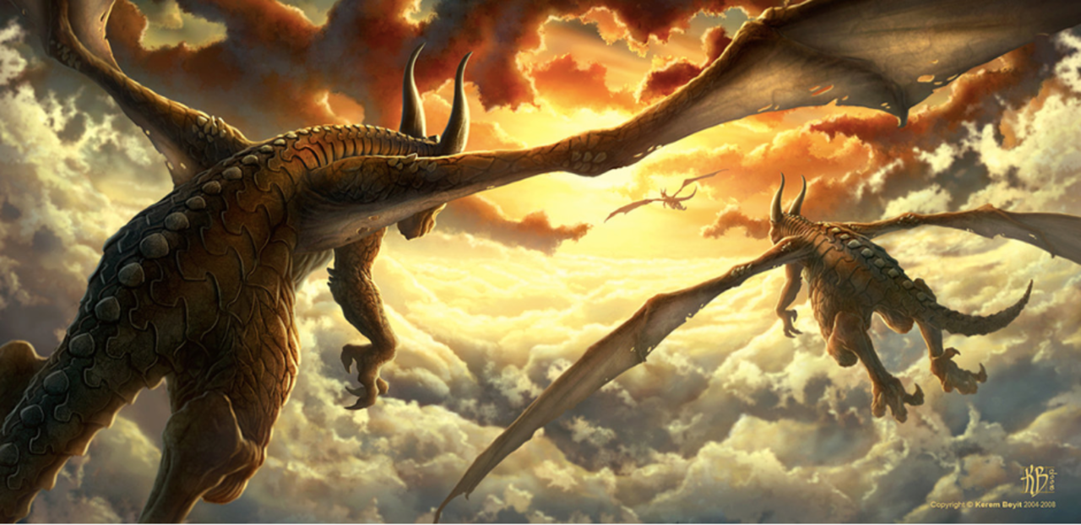

Look really carefully at the picture of the flying dragons

What questions are in your head about the picture e.g where are they going?

Try and think of five. Remember to use the capital letter at the start and the question mark at the end.

Can you write at least five really good, imaginative sentences about the picture?

Again try and include the things that you have been taught -
Fronted adverbials
Expanded noun phrases
Powerful adverbs and adjectives

Also remember the capital letters at the start and the full stop at the end.

