Monday

- 764,789 + 85,987 =
- 687,694 + 468,375 =
- 853,875 + 49,697 =
- 580,113 – 94,786 =
- 104,405 – 28,817 =
- 453,021 – 86,548 =
- 674 x 86 =
- 765 x 834 =
- 1,645 ÷ 7 =
- 1,170 ÷ 18 =

Tuesday
- Write twenty-five million, thirty-eight thousand, and four in numerals.
- Write 72,003,803 in words.
- True or False? 3,708,412 is written as three million, seven hundred and eighty thousand, four hundred and twelve. Prove it!

- True or false? 0.75 is seventy-five hundredths.
- True or false? 3.5 is thirty-five hundredths.
- Write three fifths as a decimal.
- Write 0.23 as a fraction.
- Write 46% as a fraction.
- Write 38% as a decimal.
- Write a fraction which is equivalent to 75%?

Wednesday

- $\frac{2}{5}$ + $\frac{12}{20}$ =

- $\frac{5}{12}$ + $\frac{7}{8}$ =

- $\frac{6}{9}$ - $\frac{2}{18}$ =

- $\frac{3}{5}$ x 5 =

- $\frac{2}{3}$ x $\frac{7}{8}$ =

- $\frac{8}{12}$ ÷ 3 =

- $3\frac{1}{4}$ + $2\frac{3}{12}$ =

- $6\frac{4}{15}$ - $2\frac{1}{5}$ =

- $6\frac{5}{8}$ = $\frac{?}{8}$

- $\frac{ 52}{6}$ = $?\frac{?}{6}$

Thursday

- The temperature in Sydney was 35°. In London it was -8°. What is the difference between the temperatures?

- At 4am the temperature in Portsmouth was -4.5°. At 2pm it had increased by 12°. What was the temperature at 2pm?

- The temperature decreased by 23.5° between 8pm and 6am. At 8pm it was 17°. What was the temperature at 6am?

- The difference in temperatures was 13.5°. The highest temperature was 12°. What was the lowest temperature?

- Over a period of five days, the temperature was taken at 12 midday.
Monday = 10.5°
Tuesday = 12.3°
Wednesday = 11.8°
Thursday = 15.3°
Friday = 12.1°
What was the mean temperature?

- A) The ratio of giraffes to elephants at the zoo is _______________
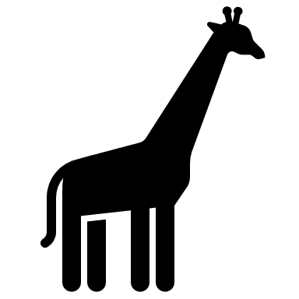

B) Using this ratio, if there are 12 giraffes in the zoo, how many elephants would there be?

c) Using this ratio, all together there are 45 giraffes and elephants in the zoo. How many of each are there?

- a) To make 1 litre of mocktail, the ratio of ingredients is: 1-part orange juice, 2- parts apple juice and 2- parts lemonade. If I used 800ml of apple juice, how much orange juice would I need?

- Using the same ratio, how much of each ingredient would I need to make 2.5 litres?

- Following the same ratio, if I used 600ml of orange juice in my mocktail, how much apple juice would I need?

- If I used 600ml of orange juice, how much mocktail would I have made all together?

Friday
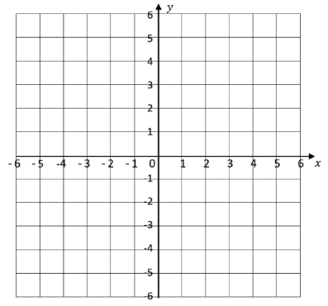
- A) Plot the given points.

A (3,-4)

B (-5,3)

C (-2,-3)

D (5,1)

- What are the co-ordinates of the shapes?
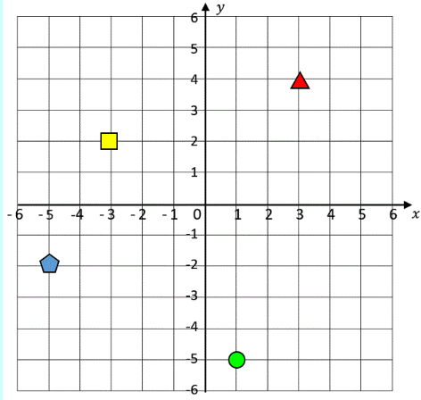

- A) How much liquid is in each jug?

_________ml _________ml

b) How much liquid is there in total? ________litres

c) What is the difference between the amount of liquid in each jug? _________ml

- A) How much does each parcel weigh?
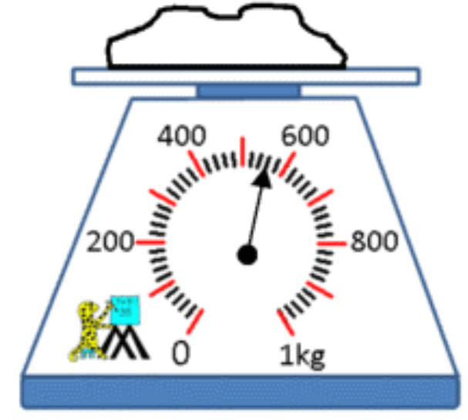
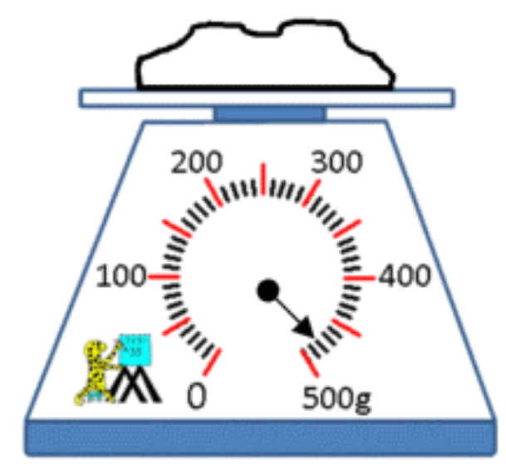
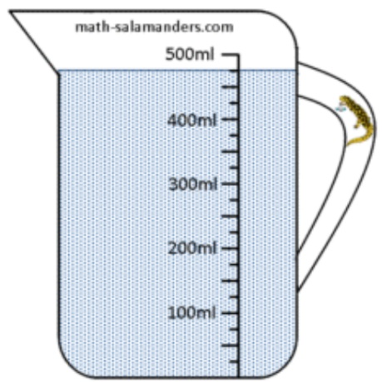
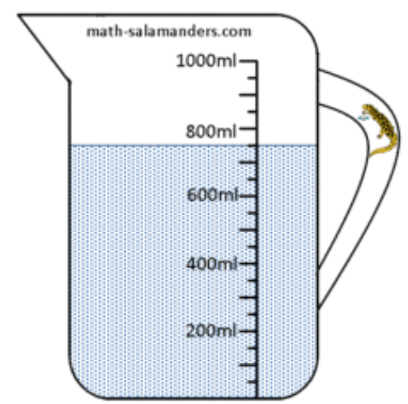

____________ kg ___________ g

b) What is the difference in weight between the two parcels?

c) What is the total weight of the two parcels?

