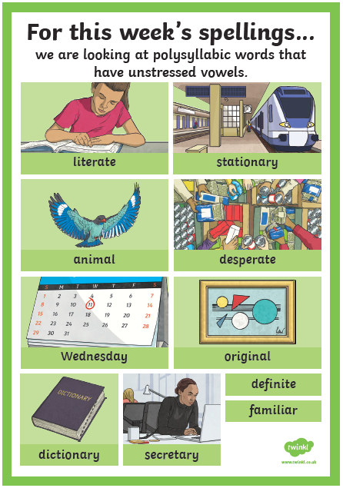
Monday 1/6/20 - Spelling
- What is a polysyllabic word?

- Find out the meaning of any of the words that you are unsure of.

- Can you sort the words in to this table?
Two syllables | Three syllables | Four syllables
- Can you add two of your own words to each column?

