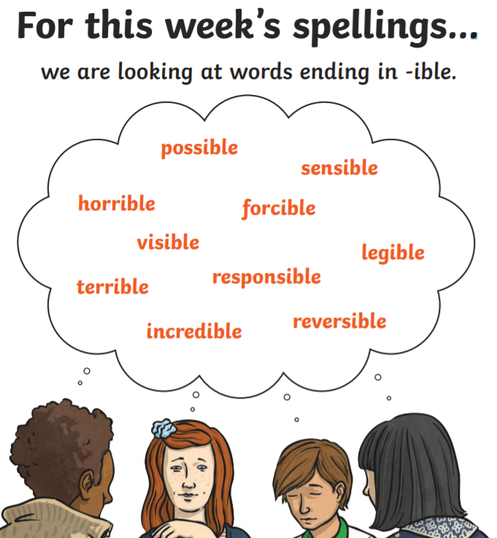

Monday 1st June

Create your own dictionary for the given spellings. Include a definition for each word.

