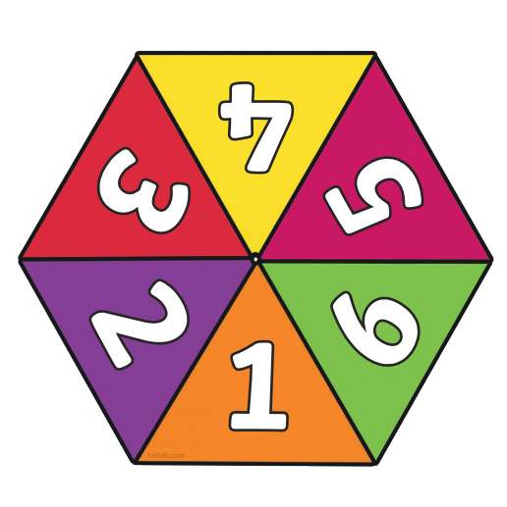

If you don’t have 2 dice at home – print these off and use a pencil with a paper clip in the middle to spin or a cocktail stick through the middle

